**Group Report of Data Compression**

1. Apply the LZ77 algorithm to compress the file ‘Introduction to Data Compression’, in which you need to include both encoding process and decoding process.
2. Please apply another method, LZ78 algorithm, to achieve the target in 1.
3. Improve the performance of LZ77 algorithm.
4. Improve the performance of LZ78 algorithm.
5. Please write a report according to your experiments. Note that in your report, you need to include the following contents:
6. The contributions of different members.
7. Some important codes for your experiments.
8. Theoretic analysis.
9. The results of your experiments.

# Contributions

|  |  |
| --- | --- |
| **Member** | **Contibutions** |
| 石望华 | 1. Implement the encoding and decoding process of LZ77 algorithm in C++; 2. Improve the performance of LZ77 algorithm by using some optimization and achieve it in C++; 3. Do some experiments based on above algorithm and write part of this report correspondingly. |
|  |  |
|  |  |

# Important Codes

## 2.1 LZ77

#### 2.1.1 C++ Implementation:

Encoding:

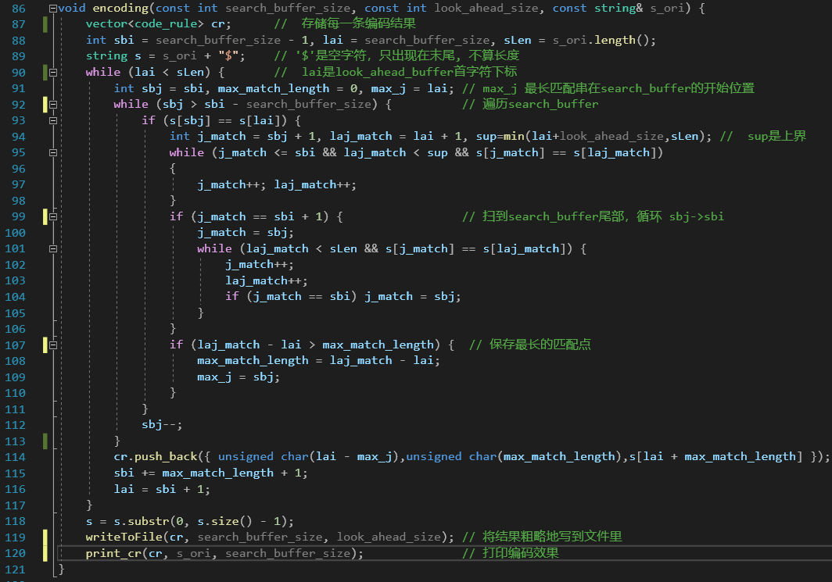

Decoding:

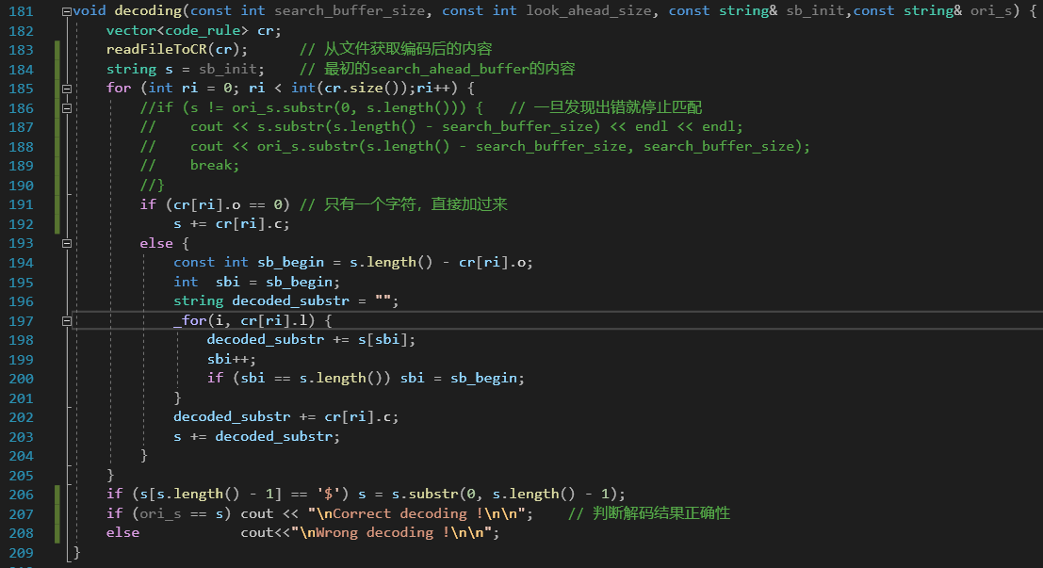

#### 2.1.2 Python Implementation:

Encoding:

Decoding:

## 2.2 LZ78

#### 2.2.1 Java Implementation:

Encoding:

Decoding:

## 2.3 LZ77 Optimization

#### 2.3.1 C++ Implementation:

Encoding:

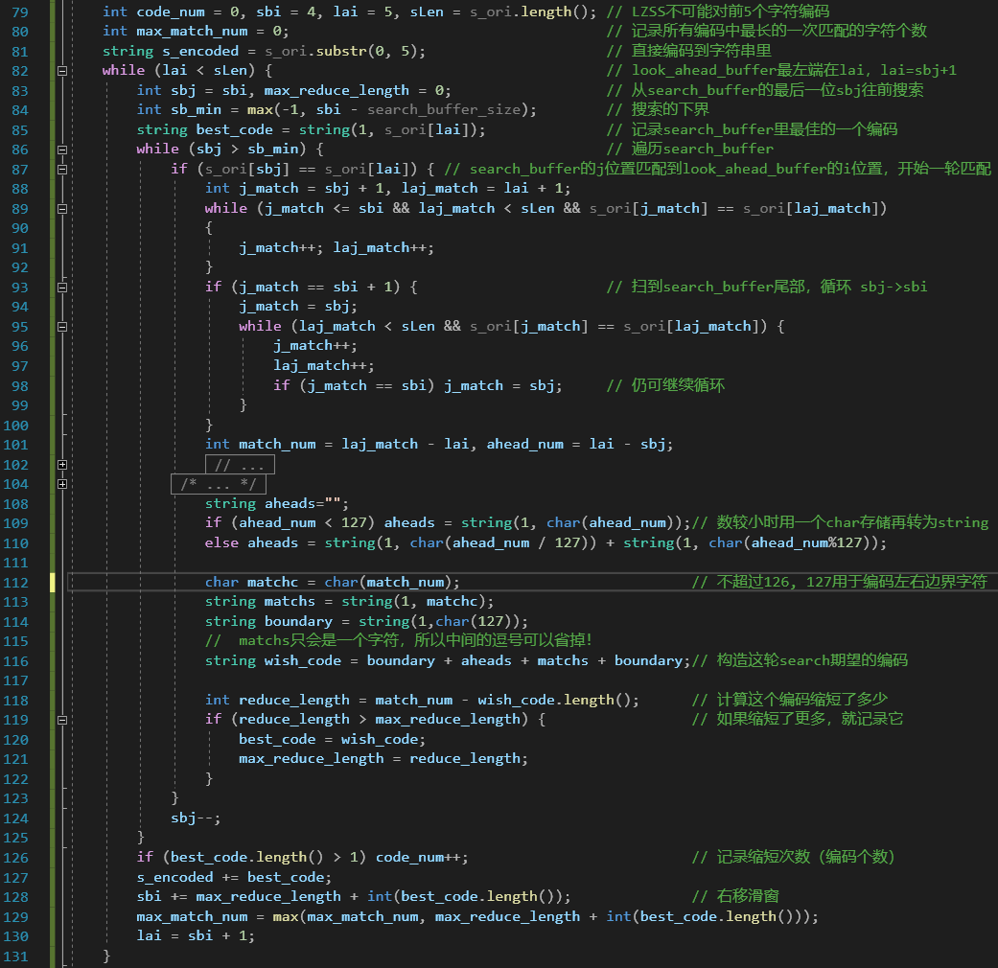

Decoding:

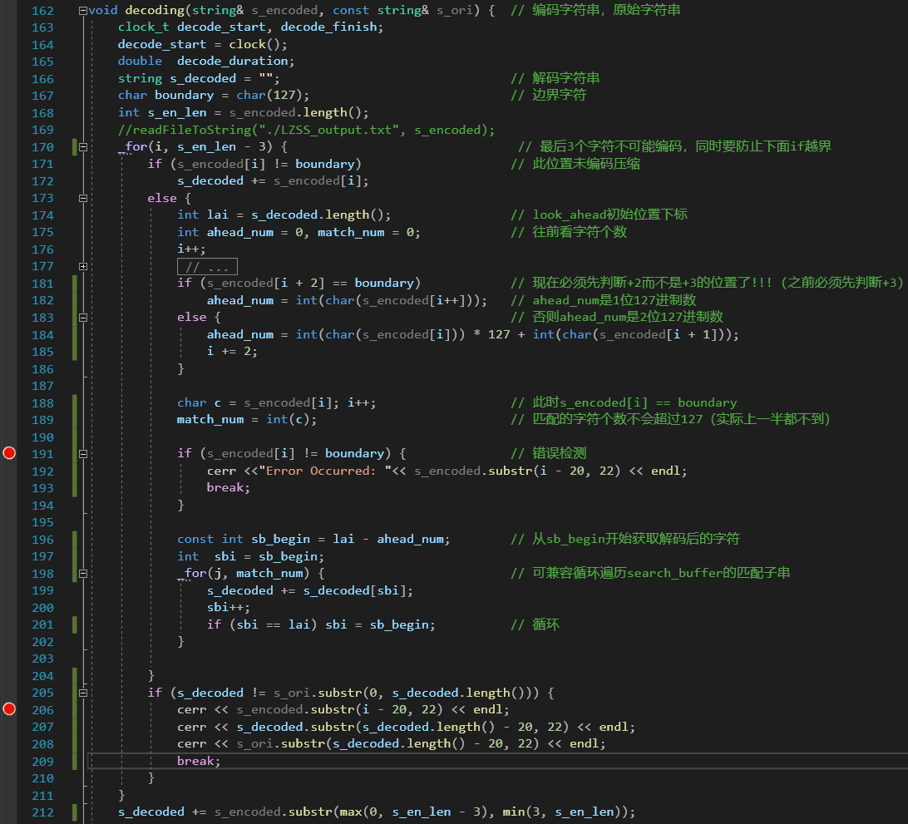

#### 2.3.2 Python Implementation:

Encoding:

Decoding:

## 2.4 LZ78 Optimization

#### 2.4.1 Java Implementation:

Encoding:

Decoding:

# Thoretic Analysis

### 3.1 LZ77 and Its Optimization

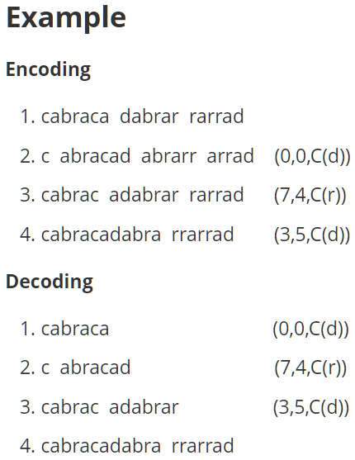

### 3.2 LZ78 Optimization

# Results of Experiments

### LZ77 and Its Optimization

#### C++ Implementation:

#### 4.1.2 Python Implementation:

### 4.2 LZ78 and Its Optimization in Java